Program 1

# Problem Statement

In this section of the overall project, we were tasked with design and implementation of a Verilog program that would emulate the reading of instruction memory. This portion of the project was the first segment in the overall completion of our MIPS simulation. This section, however had an extra difficulty as it was the first project done in Verilog by myself.

# Approach to solution

The project was very easily split up into five individual parts. Four of those parts were the actual modules in the design given to us, and the fifth “main” module was needed to combine the other four. Along with the assignment instructions we were also given a sample of code for an already implanted clock written by Dr. Goodrum, and so I was able to utilize this contribution and all that was left was the remaining four modules. The approach for this was to start with a main module and the Add module. And once those were working properly, each additional module was worked on.

# Solution Description

Much like the initial approach, the final solution was heavily split up in to five unique sections. Running the program requires Verilog be installed, and from there, the program must be compiled and run from a directory with a memory file with the name “data.dat.”. The program will then allow the clock to tick 40 times and in turn printing the first 40 8-bit words from the memory file.

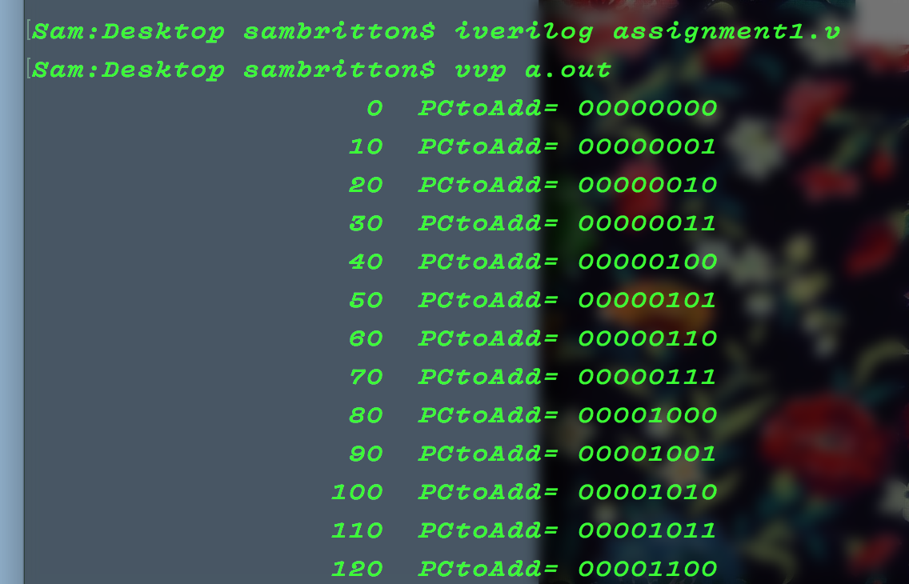

Above is the example from running the program in a directory also containing the “data.dat” file. The file itself contains the numbers 0-255 in binary, so the program is correctly outputting the contents of the file.